Short report

1.model selection

The backbone of the model is VGG16

(The source code is Implemented by keras)

Muli-label structure（VGG16）：

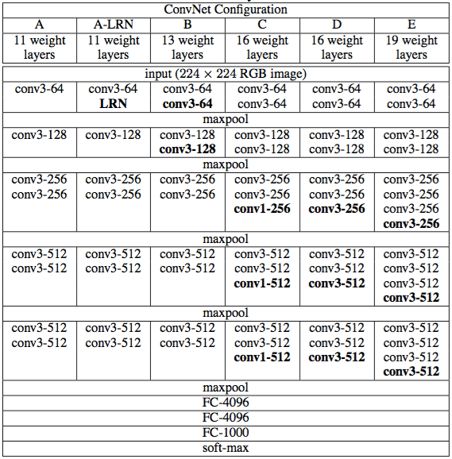

sigmoid

Vgg16 muli-label structure

Change the last layer of softmax into sigmoid activation function, and apply it to multiply labels to predict the binary output

2 loss function

binary crossentropy loss function:

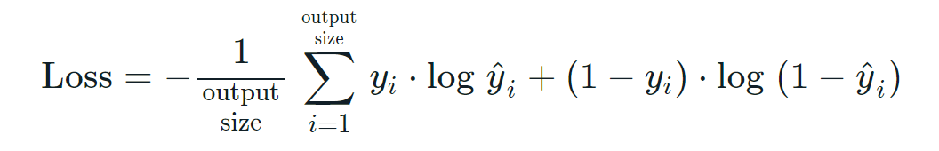

3 result

Accuracy on labels:

0.91265 0.79865 0.76825 0.82235 0.97945 0.9378 0.7683 0.8125 0.8689 0.94055 0.9494 0.85095 0.89605 0.94615 0.95685 0.98555 0.95695 0.972 0.91155 0.8411 0.9659 0.89335 0.9608 0.88425 0.9 0.7285 0.96195 0.73295 0.9274 0.9486 0.96045 0.8791 0.7893 0.78365 0.85345 0.9788 0.92195 0.878 0.9532 0.809

Average Accuracy:

0.8896637500000002